

LINUX BASH SCRIPTING LAB
(ENCS356)

Lab file Submitted to

K.R. MANGALAM UNIVERSITY

For

Bachelor Of Technology In
Computer Science Engineering Specialization (Cyber Security)
Submitted By : Abhay Rana (2301410036)
Faculty:
Dr. Rajesh Kumar



Question No. 1

Question 1: Directory Operations Problem Statement

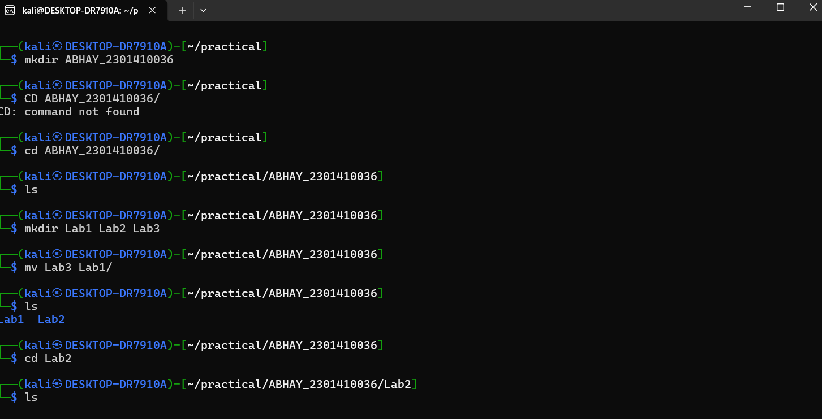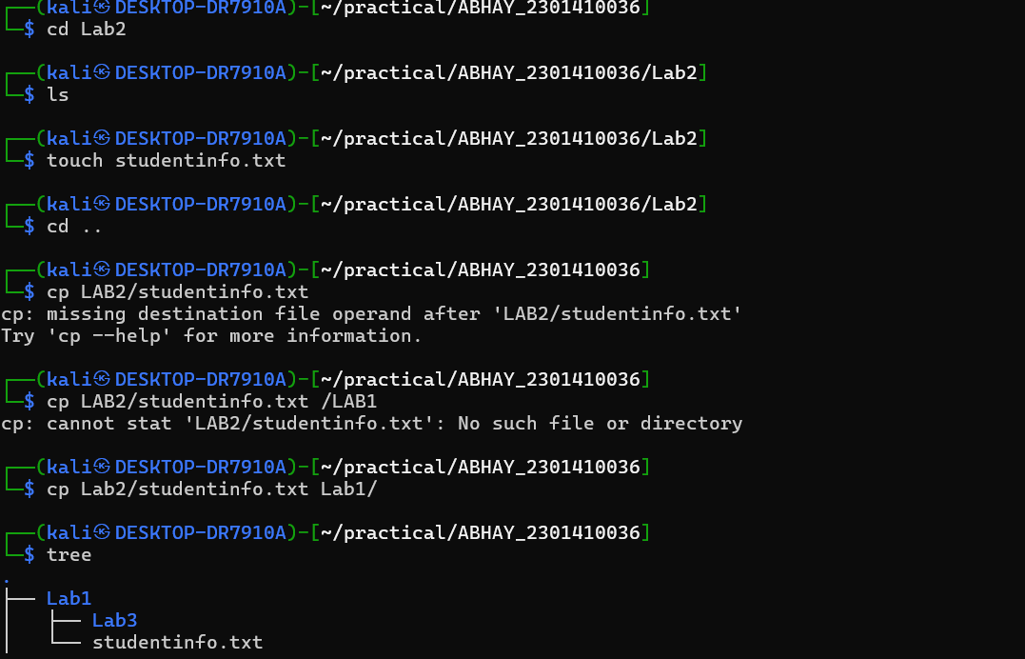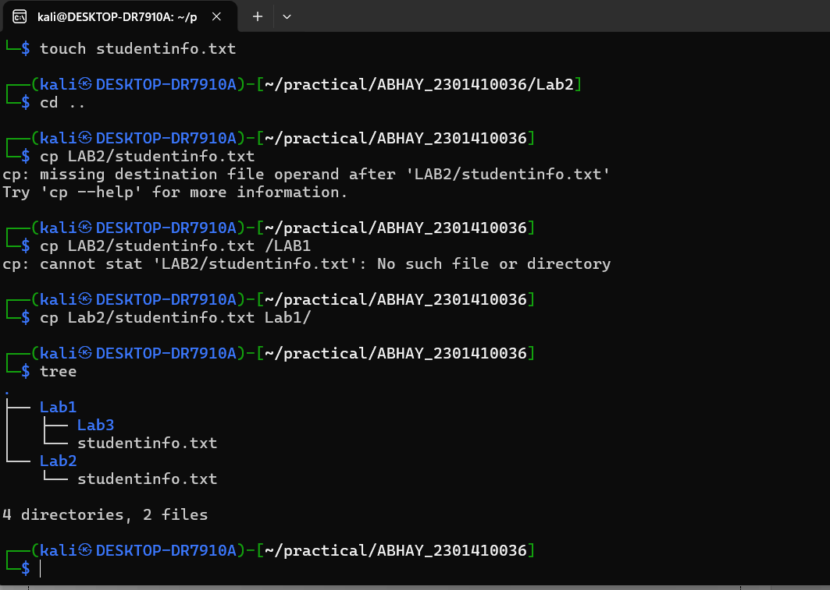

Question No. 2

Shell Script Writing

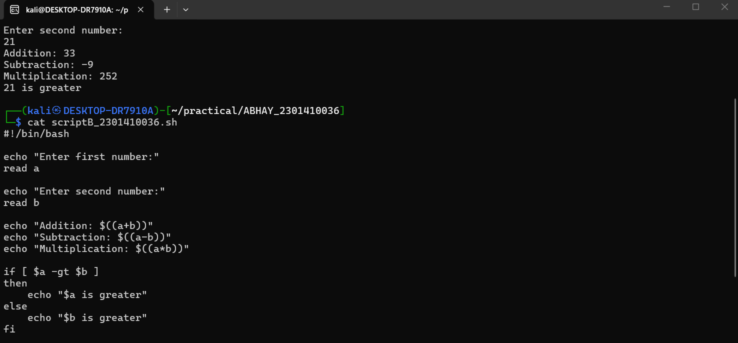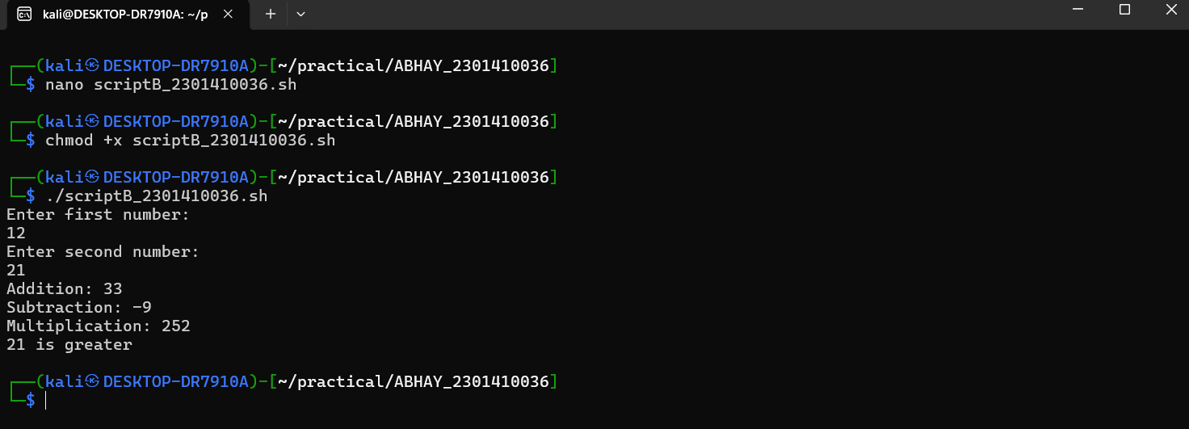

Question No. 3

Search & Filter